M15 Review Questions (RQ) Business Intelligence, and Big Data Kroenke Book Chap 12

Name: _______Liliana Varela________________

Download the attached document and answer the Review Questions (RQ).
The Review Questions (RQ) listed below can also be found in the Kroenke textbook, starting on page 526. This is NOT the entire list of Review Questions, but is a sample of 20 questions to identify the main topics in the chapter.
The M15 Quiz is NOT restricted to these questions only, so all Review Questions should be studied in preparation for the Quiz and Exam 3.
Please type your answer to the questions, in the space provided below. The questions selected provide information on the basic concepts for this chapter.
Once you have completed the assignment, enter your name at the top, and attach it to the assignment link for grading.
This assignment is worth 20 points.

M15 Review Questions (RQ) Business Intelligence, and Big Data Kroenke Book Chap 12
12.1 What are BI systems?

Business Intelligence Systems are information systems that help business professionals or companies analyse current and past activities. They also help predict future events and are used to support management assessment, analysis, planning, control, and decision making for a business and its employers.

12.3 Name and describe the two main categories of BI systems.

Reporting applications and data mining applications are two types of BI systems. Reporting systems (like OLAP) sort, filter, group, and make elementary calculations on data. Data mining applications perform sophisticated analyses on the data that usually involve complex statistical and mathematical processing in order to answer “what-if” analysis, to make predictions, and to facilitate decision making.

12.4 What are the three sources of data for BI systems?

BI applications obtain data from operational databases, extracts of operational databases, and purchased data (from data/information 3rd party vendors).

12.5 Explain the difference in processing between reporting and data mining applications.

Reporting systems summarize the current status of business activities and compare that with past or predicted future activities. They filter, sort, group, and make simple calculations and can be performed using SQL.
Data mining applications use more sophisticated statistical and mathematical techniques in order to perform analysis based on hypothetical situations, to make predictions, and to facilitate business decisions. Report delivery here is not as important because data mining applications have few users who’s computer skills are more sophisticated than most other users.

12.6 Describe three reasons why direct reading of operational data is not feasible for BI applications.

Querying operational data can slow the performance of operational systems, operational data have problems that limit their usefulness for BI applications, and finally BI system creation and maintenance require programs, facilities, and expertise that are normally not available for an operational database.

12.11 Why are data warehouses necessary?

Operational databases come with many problems such as having missing values, dirty data, inconsistency in the data, incorrect formatting, and simply having too much data. Data warehouses extract and clean operational data and store the revised data into the new data warehouse database(s).

12.14 Explain the difference between a data warehouse and a data mart. Use the analogy of a supply chain.

A data warehouse extracts data, cleans and revises the data, as well as distributes it. A data mart is a collection of data that is smaller than that in a data warehouse, but is also directed at a particular area or component of the business. While the data warehouse is like a distribution center, a data mart is like the retail store.
12.15 What is the enterprise data warehouse (EDW) architecture?

An enterprise data warehouse architecture occurs when the data mart structure is combined with the data warehouse architecture. Here the data warehouse maintains all enterprise BI data and acts an authoritative source for the data extracts provided to the data marts. The data marts receive all their data directly from the data warehouse without adding or maintaining any additional data. This process is more expensive and usually used by large organizations that can afford the costs.
12.17 What is a star schema?
Figure 12-9 illustrates a star schema:
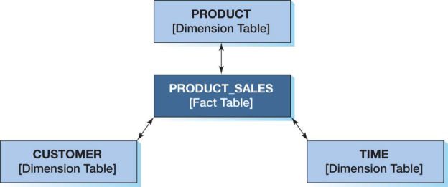

A star schema is used by a dimensional database. It has a fact table (used to store measures of business activity, quantitative or factual data) at the center and dimensional tables (used to record values of attributes that describe the fact measures in the fact table, used in queries) extending around it.

12.25 What do the letters RFM stand for in RFM analysis?

RFM stands for how RECENTLY a customer ordered, how FREQUENTLY A CUSTOMER ORDERS, and how much MONEY a customer spends per order.

12.28 What does OLAP stand for?

OLAP stands for online analytical processing

12.29 What is the distinguishing characteristic of OLAP reports?

An OLAP reports can be changed and restructured to the viewer’s liking. They can change the order of dimensions.

12.30 Define measure, dimension, and cube
A measure is the data item of interest, dimension is a characteristic of a measure, and a cube is an arrangement of measures and dimensions

12.35 Define distributed database.

A distributed database is a database that is stored and processed on more than one computer.

12.49 What is cloud computing?

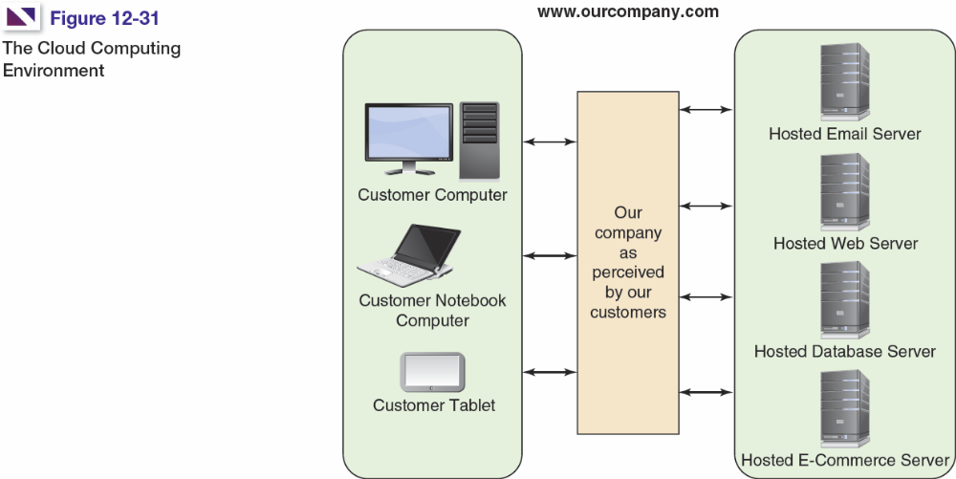
Cloud computing is a configuration of virtual server system that provided services hosted over the internet. The information is cycled between many servers in order to never lose data and provide virtually unlimited storage space for the client.

12.50 What is Big Data?

Big data essentially is very large amounts of data sets that span over many years that is stored by businesses in order to make future predictions and business decisions more accurately

12.52 What is the NoSQL movement? What are the four categories of NoSQL databases used in this book?

No SQL are non-relational databases. Four categories of NoSQL are key-value, document, column family, and graph.

12.54 What is Cassandra, and what is the history of the development of Cassandra to its current state?

Cassandra is a column family database used by the Apache Software Foundation. Facebook was the original developer of Cassandra, but in 2008 turned it into an open source project for the software development community

12.56 Explain MapReduce processing.
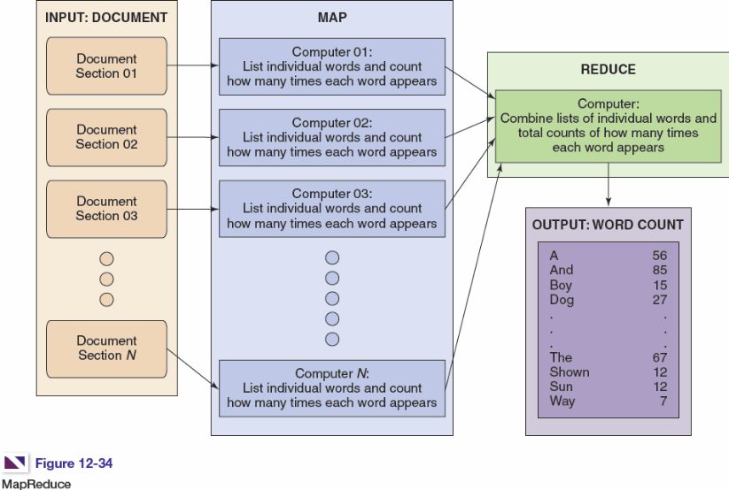

MapReduce is a process that uses a set of clustered computers. It is used to break large analytical tasks into smaller tasks and assigns each small task to a separate computer in a cluster, gathers the results of each of those tasks, and combines them into the final product of the original task.

12.57 What is Hadoop, and what is the history of the development of Hadoop to its current state? What are HBase and Pig?

Hadoop is an Apache Software Foundation project that provides standard file services to clustered serves (for Big Data) so their file systems can function as one distributed file system. It was originally part of Cassandra, but now has spun off into its own entity called HBase. HBase is the nonrelational data store that uses Pig as it’s query language. Every major player involved in DBMS is now supporting Hadoop.

